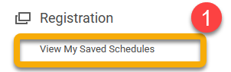
You save time and avoid mistakes by registering from a saved schedule.

Saved schedules allow you to prepare a class schedule BEFORE registration opens. Then, AFTER registration opens you can register all the course sections in your schedule as a group, instead of registering each course individually. Use this reference to view an existing saved schedule.

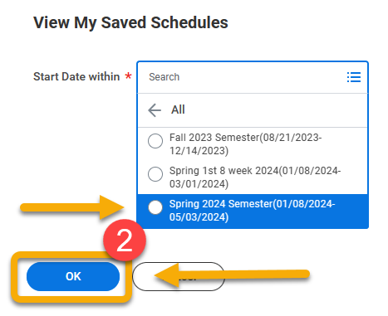
Instructions
- Click “View My Saved Schedules” under Registration.

- Select the academic period associated with your saved schedule and click “OK”.

- There is a row of helpful buttons at the bottom of each saved schedule. Click “Edit” to change course sections or to remove courses. Click “Remove” to delete the entire schedule.

- To add additional courses, click “Find Undergraduate/Graduate Course Sections” located on the Academics app homepage.

- To make sure your schedule is right for you, click “Calendar View” and your schedule will display as a calendar.

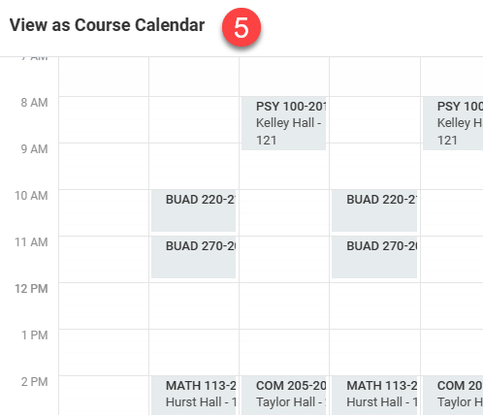

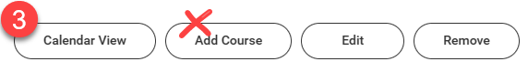
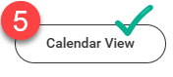
The “Add Course” button is not recommended.
You save time and avoid mistakes by registering from a saved schedule.
Saved schedules allow you to prepare a class schedule BEFORE registration opens. Then, AFTER registration opens you can register all the course sections in your schedule as a group, instead of registering each course individually.
Use this reference to view an existing saved schedule.

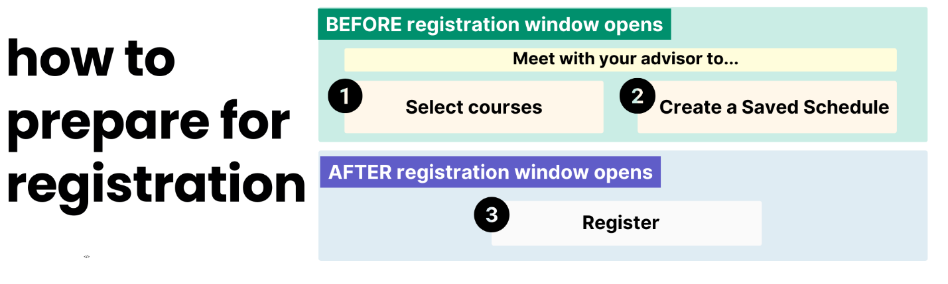

INSTRUCTIONS
- Return to the Academics App page and click View My Saves Schedules under the “Registration” heading.
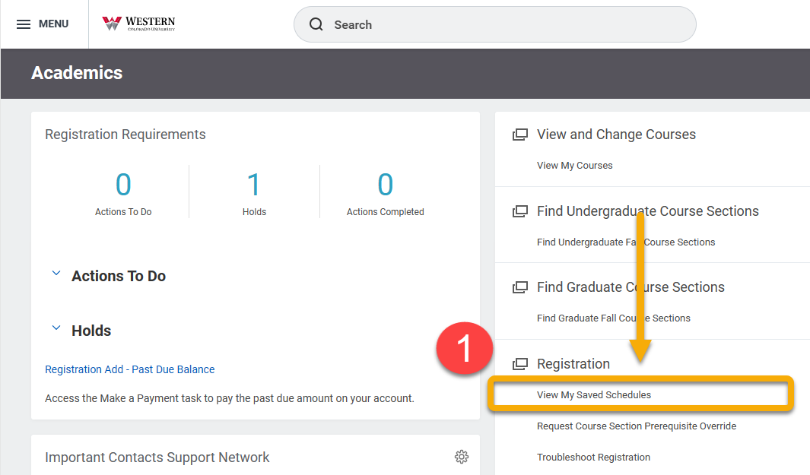

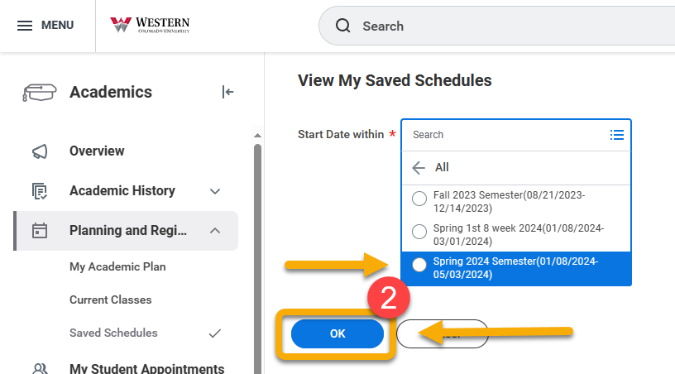
Select the academic period associated with your saved schedule and click “OK”.

On the View My Saved Schedules page, you will see all your current and previously saved schedules. Find the saved schedule from which you want to register.

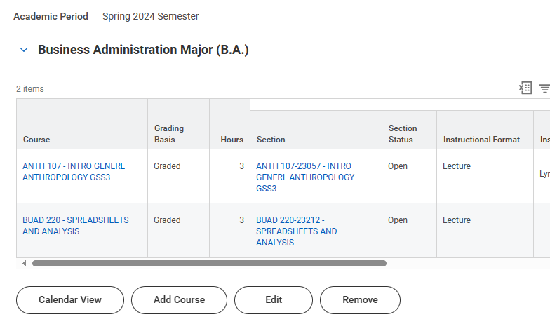

There is a row of helpful buttons at the bottom of each saved schedule. Click “Edit” to change course sections or to remove courses. Click “Remove” to delete the entire schedule.

If you want to add a course, click “Find Undergraduate/Graduate Course Sections” located on the Academics app homepage.

 The “Add Course” button is not recommended.
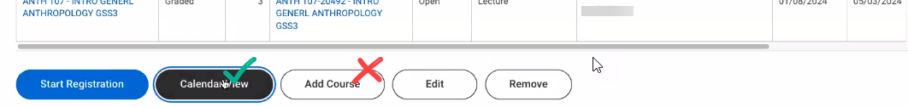

The “Calendar View” button is very helpful. To make sure your schedule is right for you, click “Calendar View” and your schedule will display as a calendar.
